**Deployment Guide**

Contents

Create roles having permission to create cloud formation templates 1

Create bucket to contain source code in a zipped file 6

Create bucket to contain lambda function deployable 11

Create base stack 12

Create main stack 14

## Create roles having permission to create cloud formation templates

* Log in to your AWS account.
* Navigate to Services > IAM > Policies:

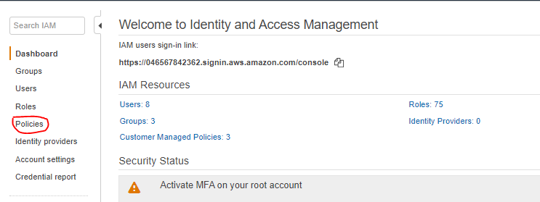

* Click on create policy:

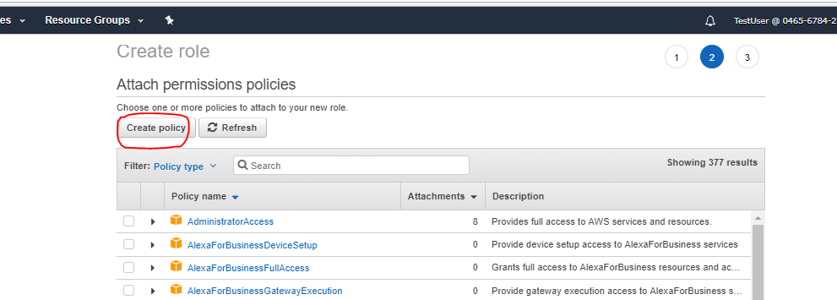

* Choose Service as CloudFormation
* Choose Actions as: List, Read, Write
* Click on resources :

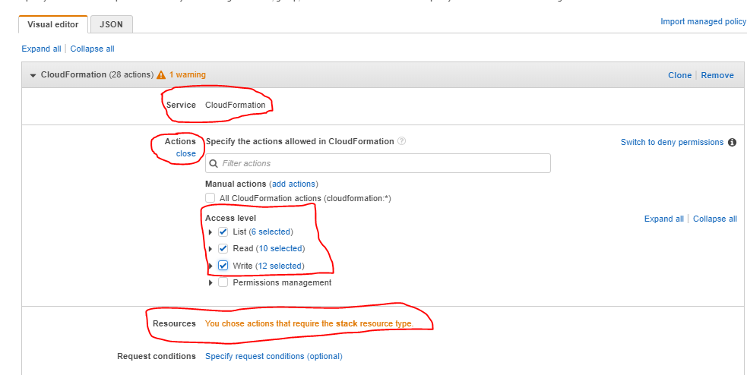

* Select all Resources > Review Policy:

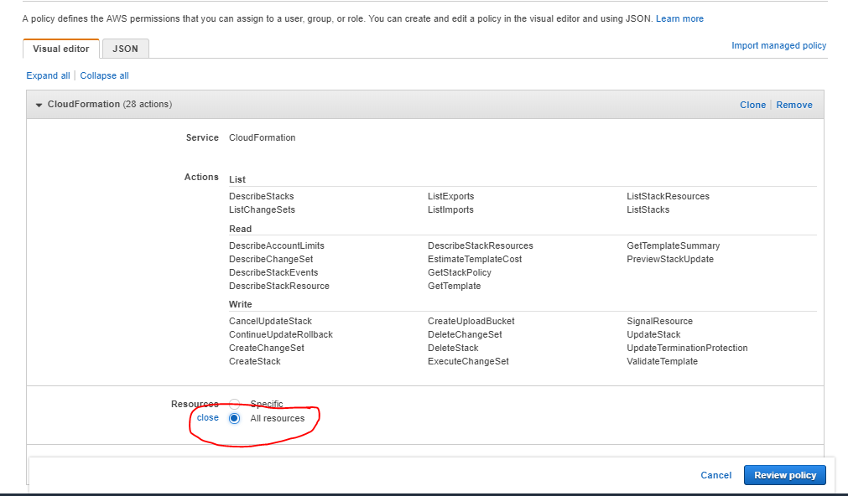

* Add Policy Name > Create Policy:

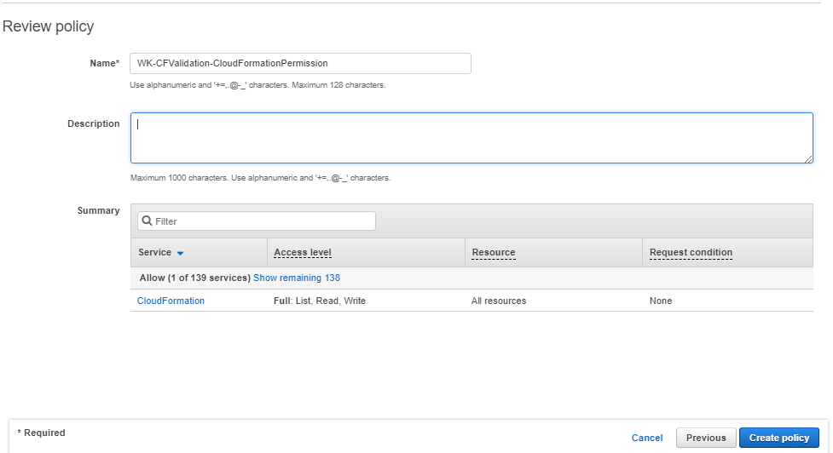

* Navigate to Services > IAM > Roles:

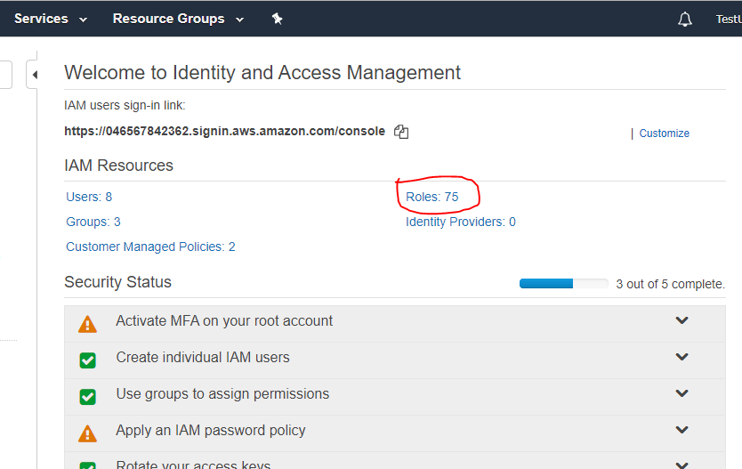

* Click on Create Roles:

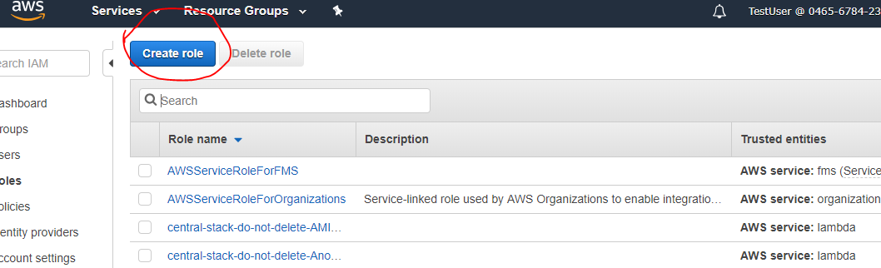

* Choose AWS Service > Cloud Formation > Next

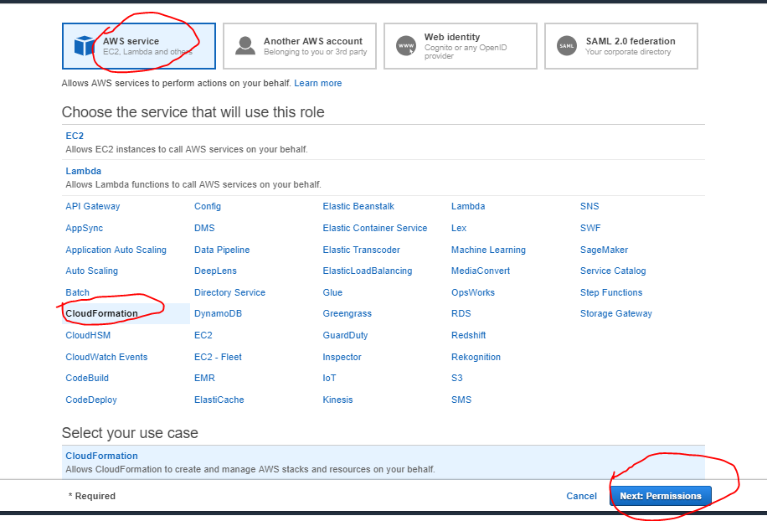

* Search for the Policy created in the above step and select:

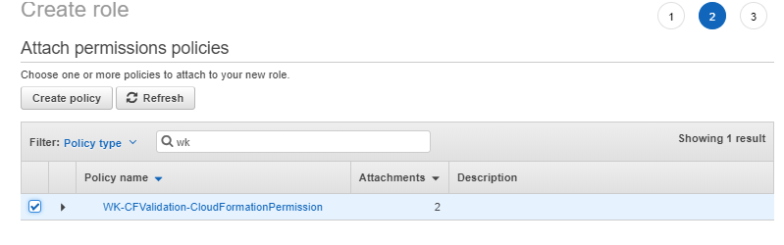

* Search for the S3 Full access and select that > Review:

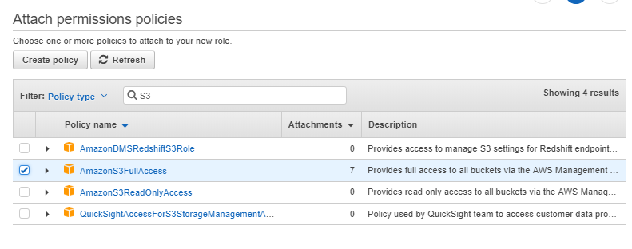

* Add role Name > Create Role

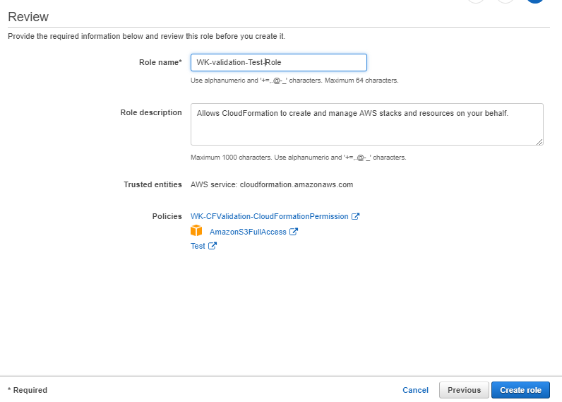

## Create bucket to contain source code in a zipped file

* Log in to your AWS account.
* Navigate to Services > S3

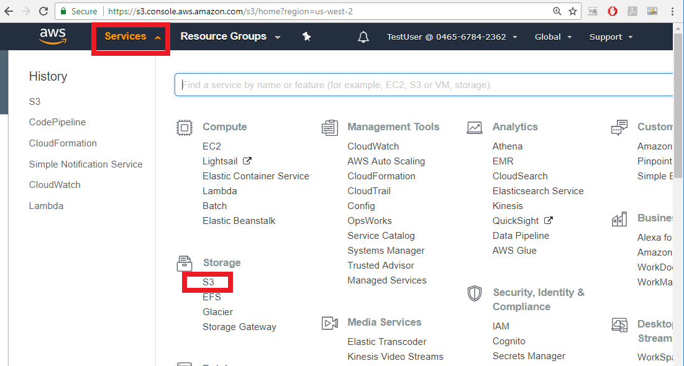

* Click on Create bucket

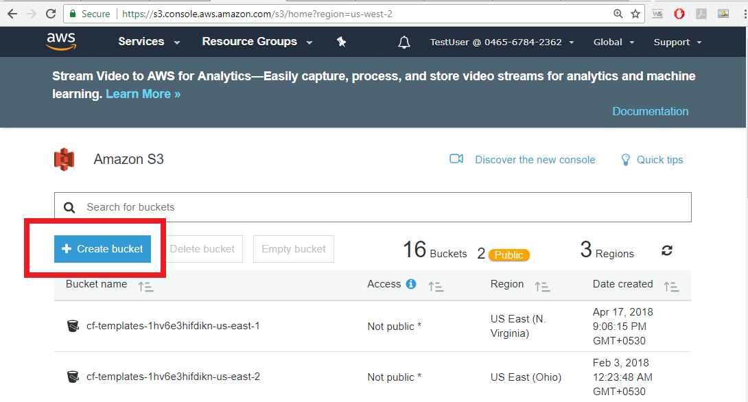

* Enter Bucket Name and choose region > next

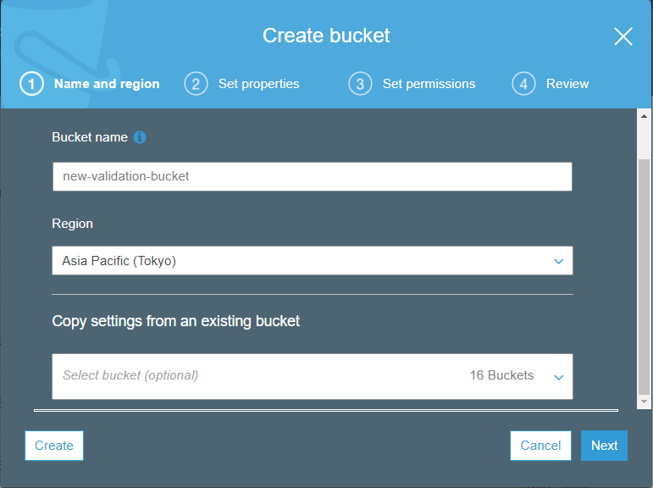

* Click on versioning to enable it > Save > Next

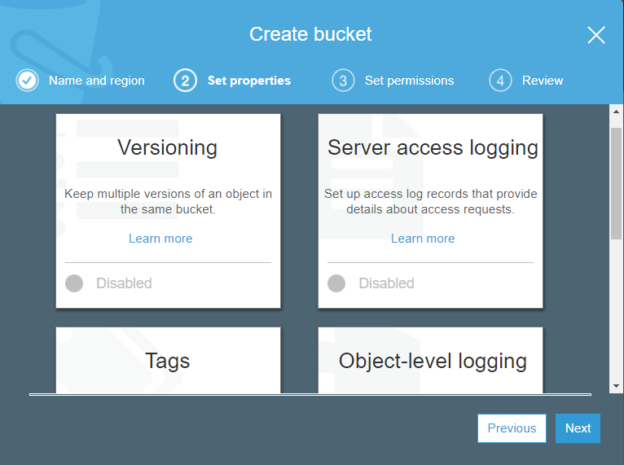

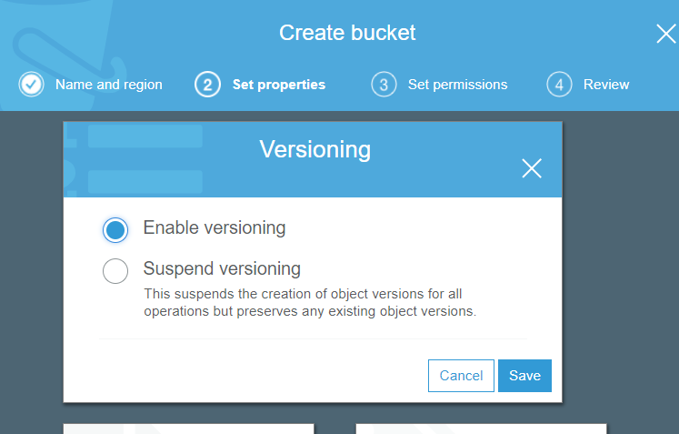

* Do not grant public Permissions > Next

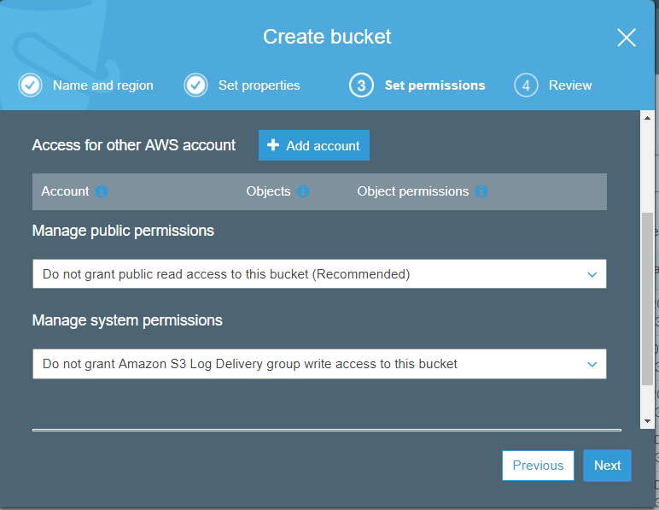

* Review > Create Bucket

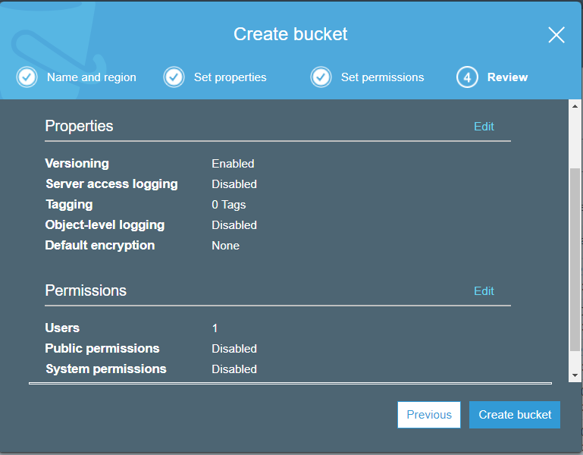

* The bucket will be created in the region of choice:

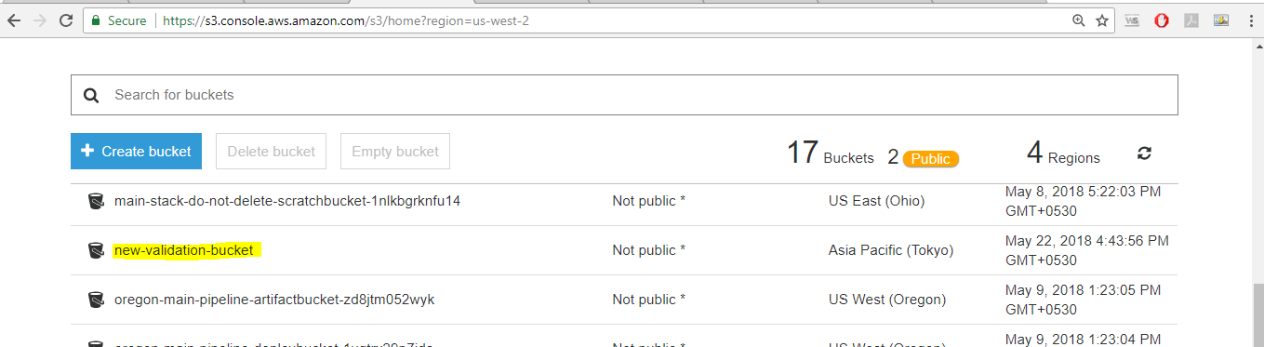

* Navigate into the bucket policy:

Amazon S3 >> [*<bucket-name*](https://s3.console.aws.amazon.com/s3/)*-you-created> >>* Permissions >> Bucket Policy

Add a policy similar to the one below:

{

"Version": "2012-10-17",

"Id": "Policy1525345212541",

"Statement": [

{

"Sid": "Stmt1525345208127",

"Effect": "Allow",

"Principal": {

"AWS": [

"arn:aws:iam::046567842362:user/<User-Name>",

"arn:aws:iam::046567842362:role/<Role-Name created in Step 1 above>"

]

},

"Action": "s3:*",

"Resource": "arn:aws:s3:::<Bucket-Name>/*"

}

]

}

* Navigate to the bucket and upload the zipped file:

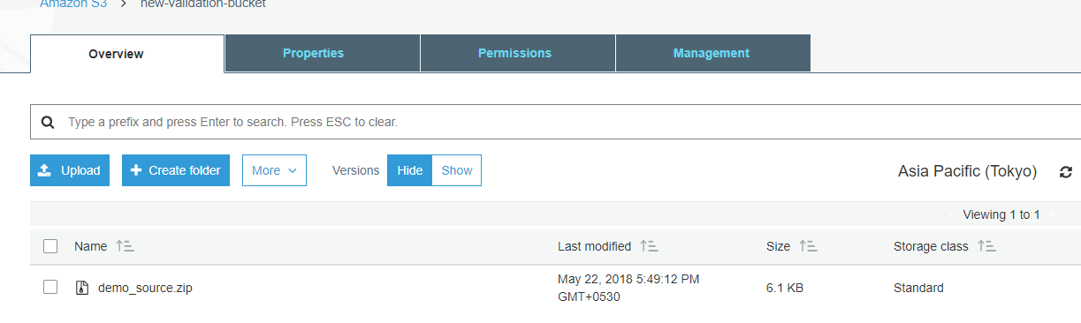

## Create bucket to contain lambda function deployable

* Create another bucket as described above in the same region.
* This bucket will contain all lambda functions
* Create a folder named “lambda_functions”
* Upload all lambda function deployable (.zip files) in the lambda_functions folder

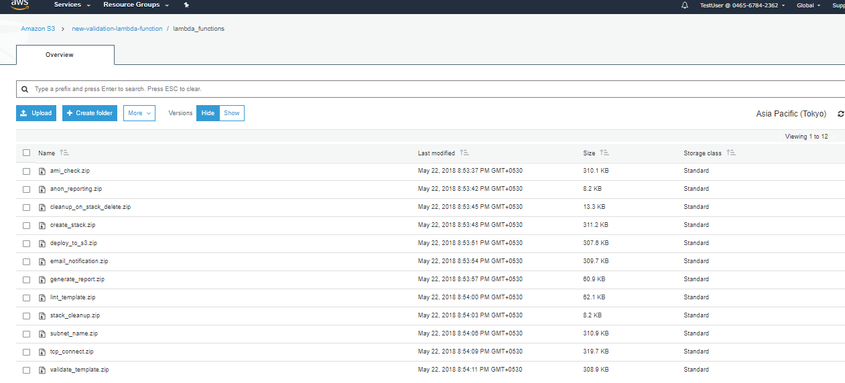

## Create base stack

* Login to AWS account.
* Navigate to Services > CloudFormation
* Select the region where the bucket was created.
* Click Create Stack:

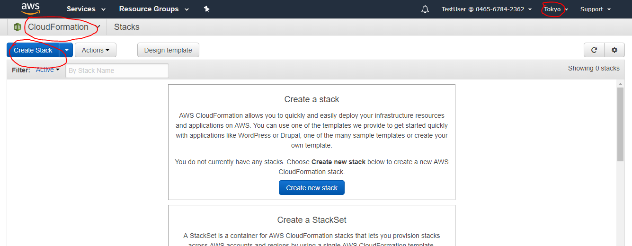

* Choose “Upload a template to Amazon S3” and click on “Choose File”
* Navigate to central-microservices.template > Next

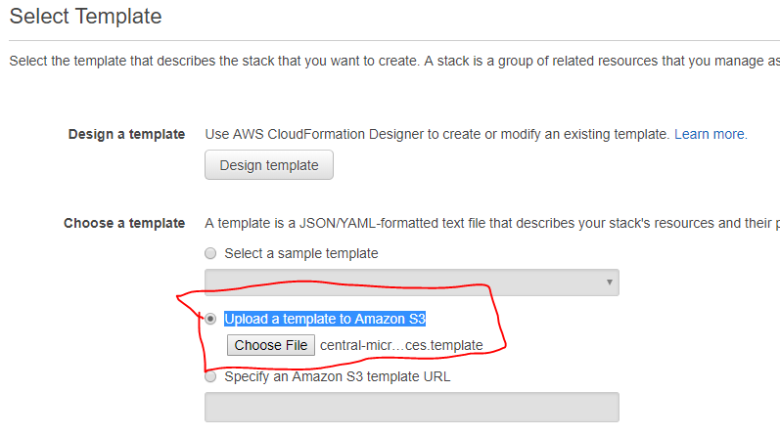

* Add Stack name, provide the arn of the role created in step 1 and supply the name of the S3 bucket containing the lambda function deployables > Next > Next

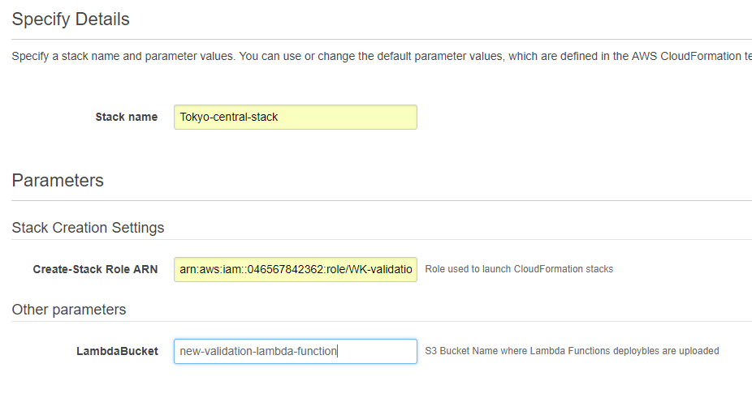

* On the Review page select the checkbox “**I acknowledge that AWS CloudFormation might create IAM resources.” > Create**

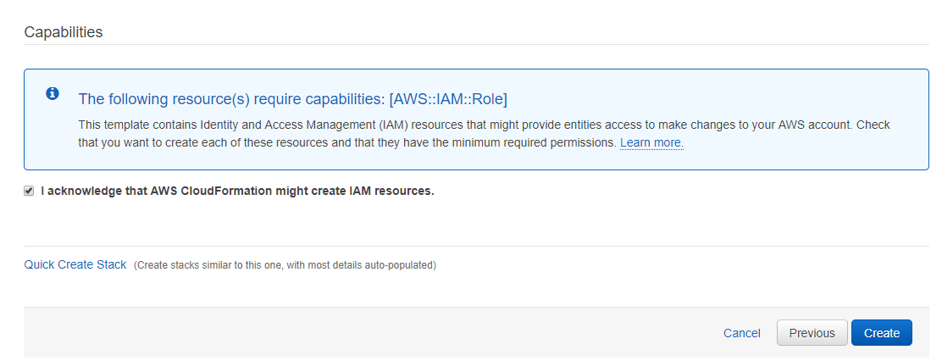

* Stack will be created in the chosen Region:

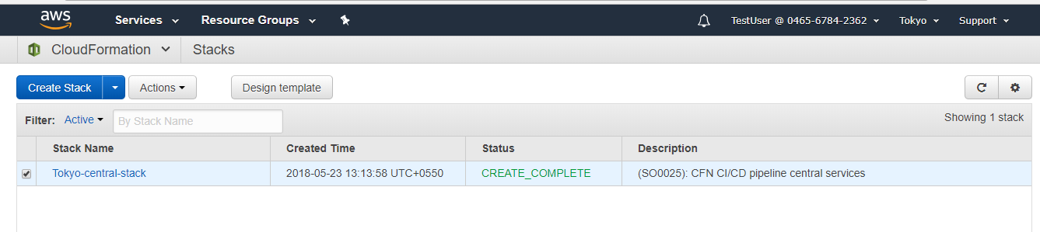

## Create main stack

* Login to AWS account.
* Navigate to Services > CloudFormation
* Select the region where the bucket was created.
* Click Create Stack
* Choose “Upload a template to Amazon S3” and click on “Choose File”
* Navigate to main-pipeline.json> Next
* Add the following details:
  + - Stack Name
    - Change the bucket name to point to the bucket containing the manifest.zip
    - Add Primary and secondary emails
    - Supply arn of the role created in step 1
    - In **Logical (pre-stack-create) Tests** section in 1st Test provide the value “Lint_Template”
    - Add Lambda Bucket name to point to the bucket containing Lambda funtions
    - Leave all other values to default > Next > Next

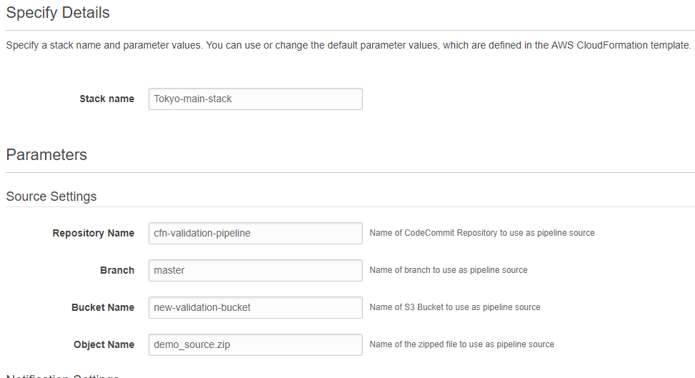

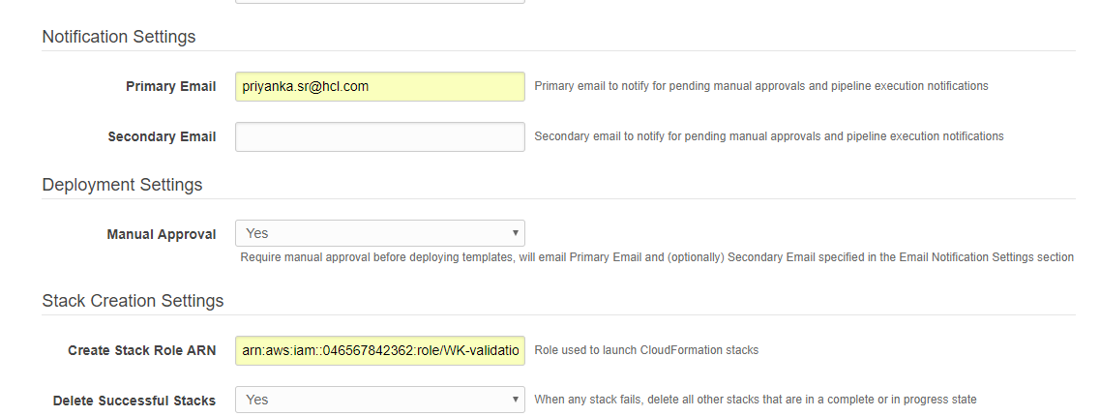

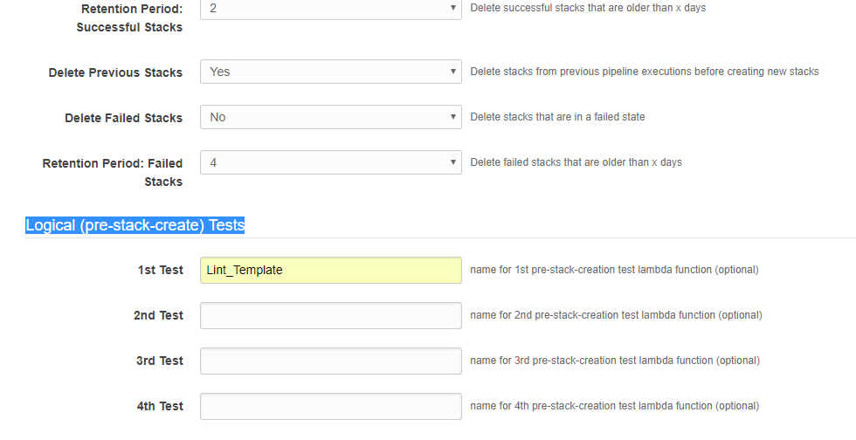

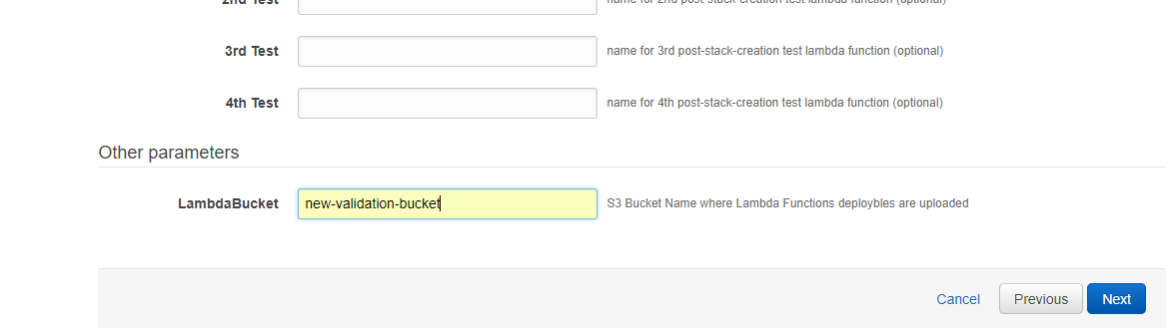

* On the Review page select the checkbox “**I acknowledge that AWS CloudFormation might create IAM resources.” > Create**
* **The Stack will be created successfully.**

Note:

1. On successful creation of the stack an email will be send to the primary/secondary email provided during stack creation using which the user needs to subscribe to the topic to receive any alerts. No alerts will be send to these email addresses if the user dose not subscribe to the topic.

2. On successful creation of the stack, a code pipeline will be created in the same region. If there is a manifest.zip in the source bucket, the pipeline will start execution automatically.